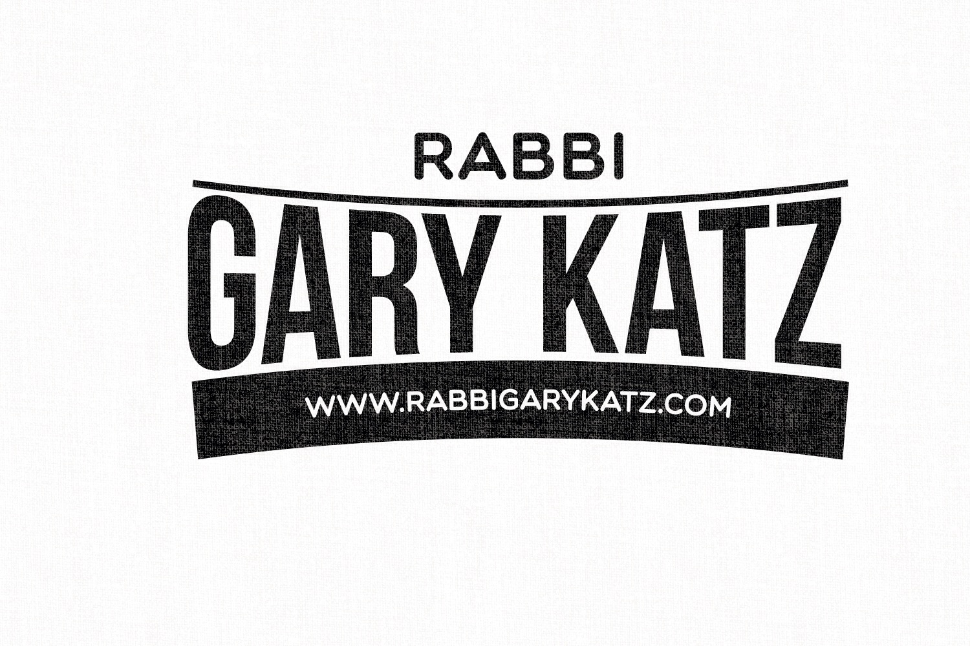

Dear Friends and Families,

I hope that you are enjoying your summer. The High Holidays are approaching and as last year's services proved to be meaningful experiences I am excited to share that we will once again be holding High Holiday services this Fall.

The dates and times are as follows:

September 25th - 1st Day Rosh Hashanah 10:00 am - 1:00 pm
October 3rd - Candlelighting & Kol Nidrei Service - Yom Kippur Eve 6:00 - 7:30
October 4th - Yom Kippur 10:00 am - 1:00 pm and
N'eilah service at 6:00 - 7:10 pm

Cindy and Gregg Wolfer have graciously offered to host the services again at their home which is at 48 Kennedy Road, in Cresskill, NJ.

As was designed last year, services will be geared for families and will be educational, explanatory & meaningful at the same time. Both adults and children will have the opportunity to participate, help lead, or ask questions during the service at a level they are comfortable with. This is a very different experience than coming to a service where you watch as part of the “audience”, try and figure out what’s happening, and count the pages to see how long until it is over. It should also be noted that this is not a "kiddie service geared towards tots or very young children. My hope is that younger children will be able to participate with their families but there will also be some activities for them as well during the service.

Each service will contain an educational piece, a prayer service including Torah reading, a shofar service (on Rosh Hashanah) and a group discussion in small groups of families.

This year we are adding a few new things;
1) Cantor Avital Lazar who graced us with her beautiful voice last Yom Kippur will be joining us for all of our services on both Rosh Hashanah and Yom Kippur.
2) We will be adding on a N'eilah service at the conclusion of Yom Kippur followed by a breakfast meal to give families an opportunity to socialize and connect with one another.

As it is focused on families, the pricing is $425 per family which includes all extended family for all or any of the four services. Please feel free to bring any extended family, your parents, grandparents, even that Aunt or Uncle that you always feel a responsibility to include at your family events.

My goal is for it to be a spiritual experience for everyone regardless of background, education and level of observance where each of us can explore our Jewish identity as individuals and as a small community.

Please feel free to contact me at this email address (rabbi@rabbigarykatz.com) or via phone
at 201-410-2629 with any questions you may have.
Wishing all of you a happy and a healthy New Year as well as a year of peace and safety for the Jewish people.

Warmly,

Rabbi Gary Katz

Rabbi Gary Katz
http://rabbigarykatz.com/
201-410-2629
A rabbi for every occasion.
A relationship for life.
Serving the Greater Tri-State Area
(NY, NJ, CT)

To reserve a seat, please mail back this sheet with the information completed below and payment to:

Rabbi Gary Katz
187 Oxford Road
New Rochelle, NY 10804

We will be attending the following High Holiday services this year.

_______ September 25th - 1st Day Rosh Hashanah 10:00 am - 1:00 pm
_______ October 3rd - Candlelighting & Kol Nidrei Service - 6:00 - 7:30 pm
_______ October 4th - Yom Kippur 10:00 am - 1:00 pm and
_______ N'eilah service at 6:00 - 7:10 pm

The following people will be attending:

____________________________________________________________________________________________________________________________________________________________________________________________________________________________________________________________

